**\*DRAFT\***

Since Peopoly built Moai kit to test print before shipping, the leveling should already be close to optimal. Following steps are to help you check leveling and make small changes if needed. You should run the check again when you change vat

Steps

1.

Download this gcode and placed it in the SD card’s Gcode directory

<https://drive.google.com/file/d/1REhwgXPzffKO1UOH15q6oeZvWlj-A3Lv/view>

You will find this gcode

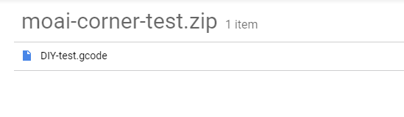

2.

Install build plate on Moai and make sure the knob is tightened.

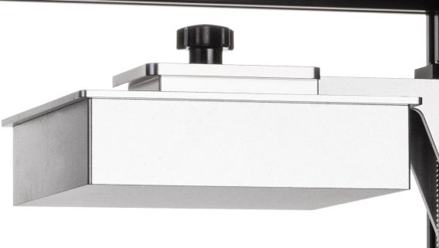

3.

Locate the resin vat package and take out the vat. Make sure do not touch the bottle part of the vat.

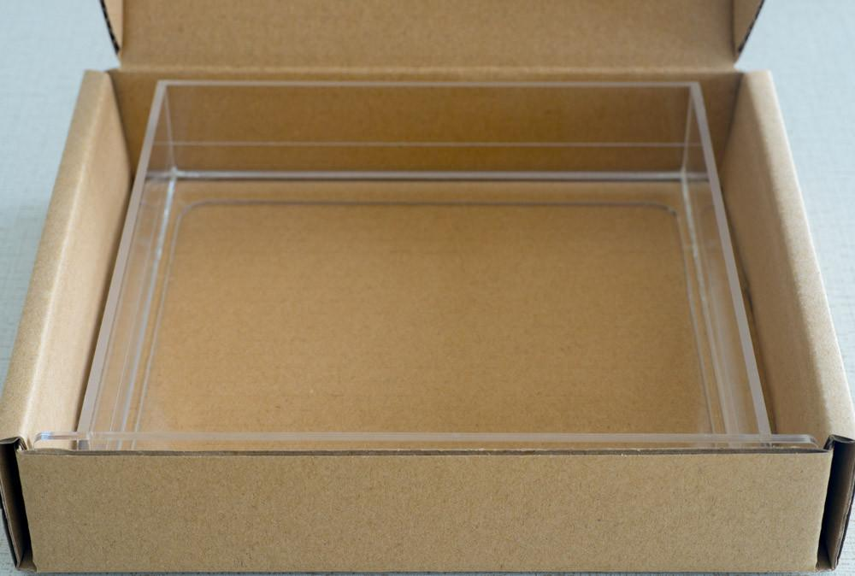

4

Take out the resin bottle that looks like this:



Shake well before open it for about 30 seconds and then pour resin into the vat:

The printer setup would look like:

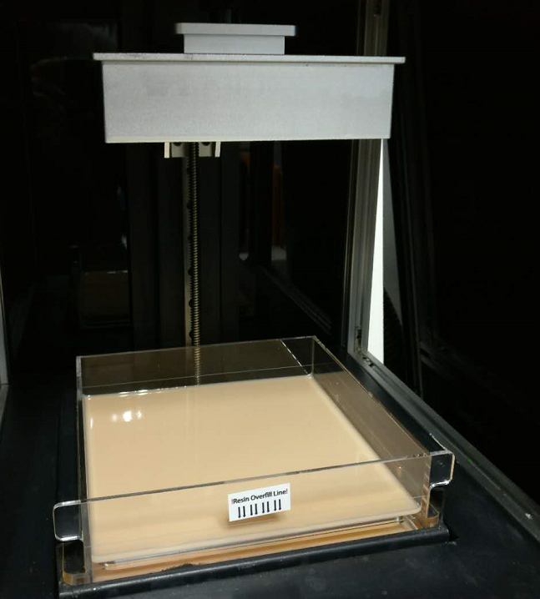

-

Now insert the SD card to Moai and power it on by pressing the power button

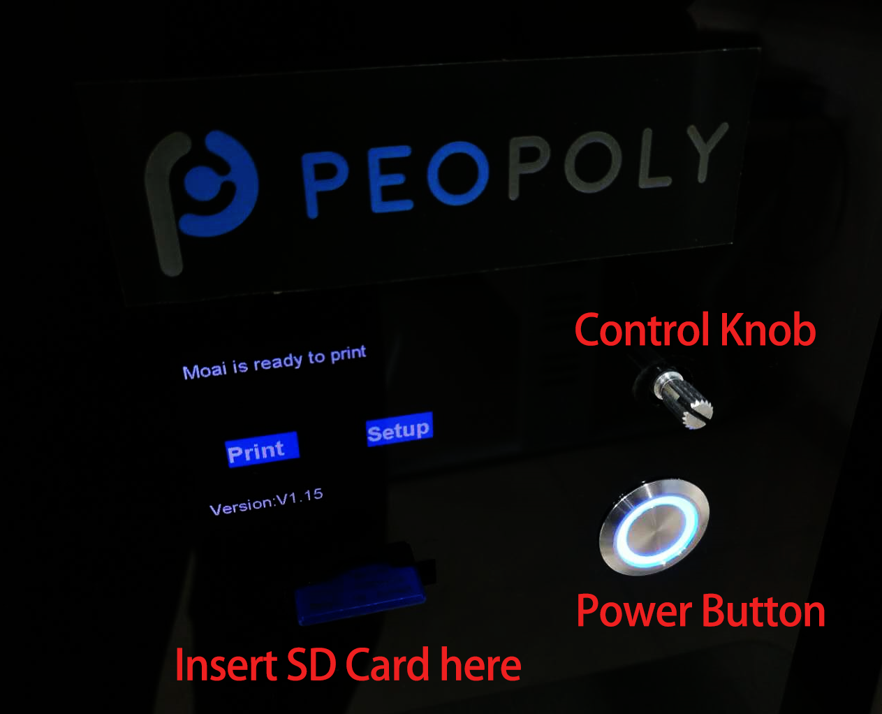

Print the gcode by using the control knob to

1. select print
2. Select gcode directory
3. Select DIYTest.gcode file

This print takes about 20 minutes.

This is gcode contains 4 small cylinders, one at each corner of the built plate labeled ABCD.

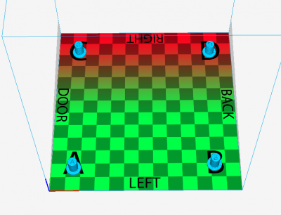

The lettering represents their location on the built plate. This helps you identify them when they are removed from the build plate.

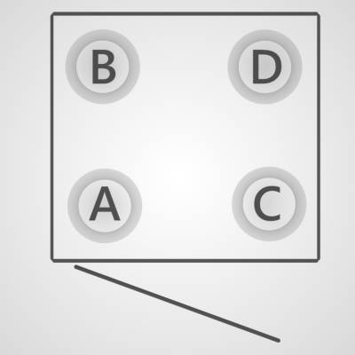

The way to use these cylinders is that we want the printed cylinders to have a height of 10.6-10.8mm. The height of the cylinder tells us how much pressure is placed on the PDMS layer.

When the print is finished. They should look like this when build plate is facing up to the ceiling:

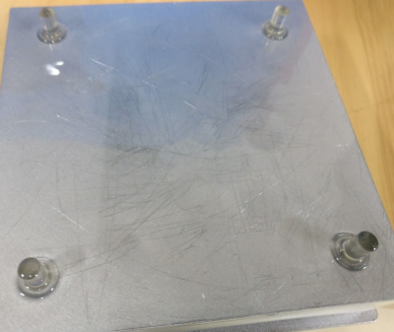

Check location by removing and cleaning (using Ethanol or IPA) one at the time and match them to this picture. If they don’t match, make sure you are holding the plate in the right direction.

Once you got all 4 cylinders removed and cleaned from the plate, go ahead and measure their heights and marked them by A, B, C, D.

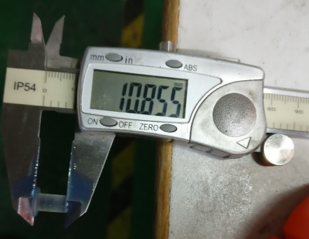

For example, you may have A 10.4mm B 11.0mm C 10.65mm D 10.0mm

This set of number represents how your Moai is leveled. You can use it to help you get to optimal level (10.6 – 10.8mm) and share with those who are trying to assist you.

To adjust, first find the tools for adjustment. Locate this screwdriver from accessory box.

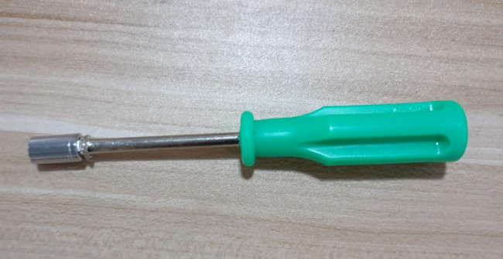

Then you have to look under the build plate form and find the screws like these.

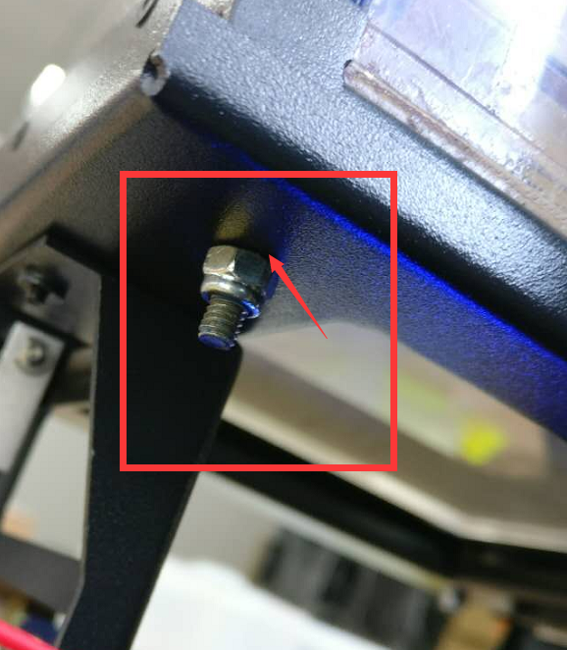

There are one under each corner under the vat. The amount of adjustment to each nut is based on the difference between current cylinder height. This diagram can help you visualize better.

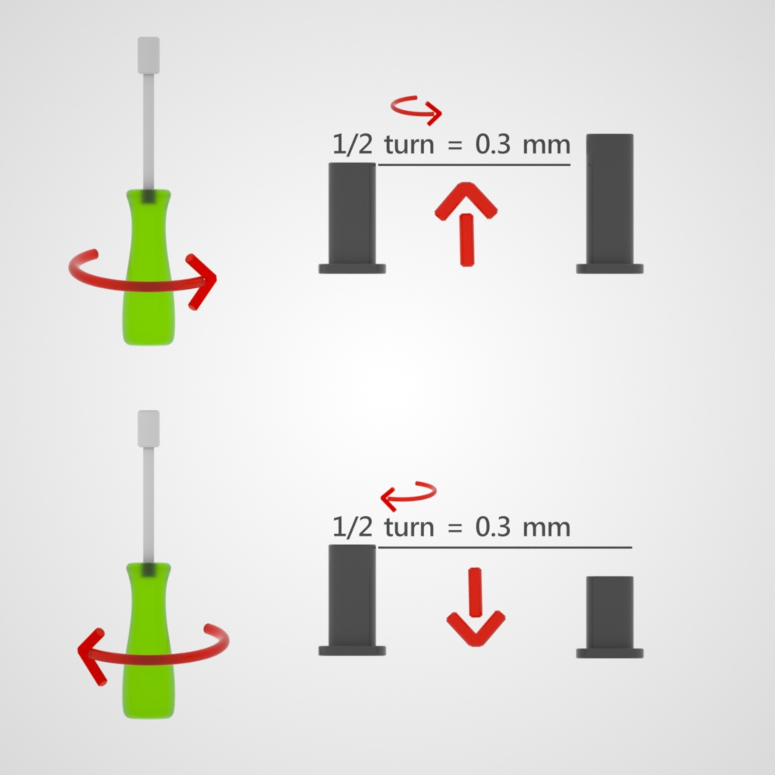

Using above measurements as example

To adjust A corner, find the nut under A’s corner and turn it.

Since A is off by 10.4 – 10.75 = 0.35mm. half turn tightening is 0.35mm increase in cylinder height. You make 1 half turn, and we can ex

B corner cylinder is 11mm. We can do half turn loosening of the nut to decrease the height by 0.35mm. Turning it to 10.65mm

C corner cylinder doesn’t need any adjustment

D corner is 10-10.7 = - 0.7mm. We can do a full turn of tightening of the nut to increase the height of cylinder to 10.7mm.

After adjustment, print the 4 cylinder gcode again, measure and adjust. Repeat this process until you have all 4 corners to be between 10.6 to 10.8mm

Thoughts for improvement.

Adjust cylinder design so that optimal printed height is 10mm. This is easier for the user to calculate.